National Pathology Week 2014- Nutrition Symposium
Event Feedback
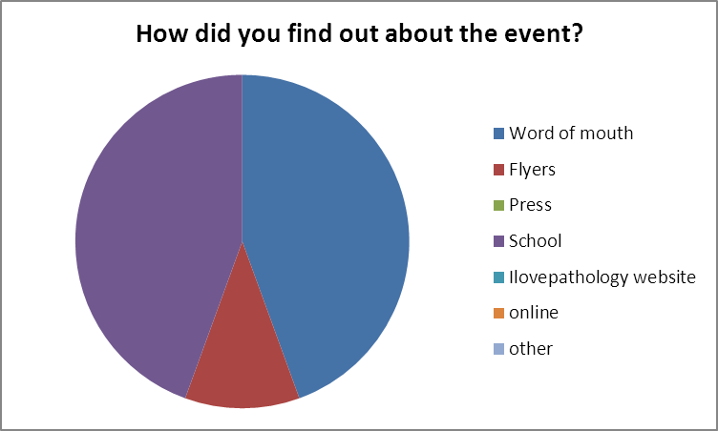
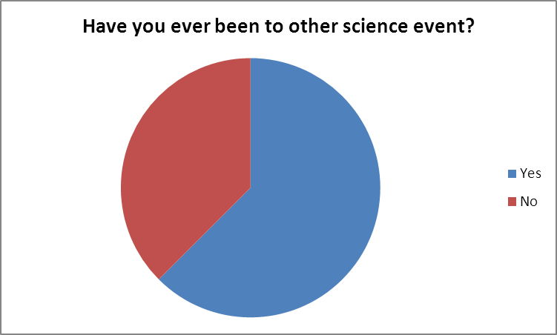
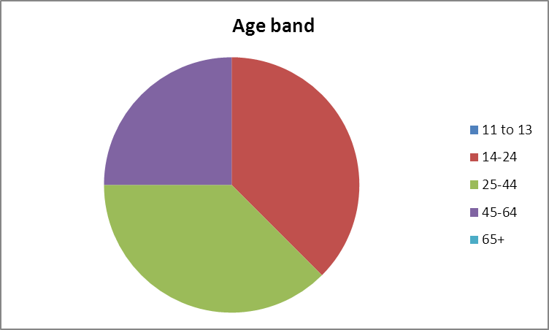
All users found the event very interesting, enjoyable, clearly presented and satisfying overall.
All users replied that they have learned more about pathology and would attend a similar event after this symposium.
Comments:
Found the course very interesting and has updated my knowledge
Taught me how as a student nurse I can take part in ensure patients receive adequate nutrition for their various health conditions
More detail on nutrition requirements and how they change in disease sates and on the composition of nutritional support products and in what scenarios to use each one
I enjoyed the practical demonstrations, I found it very useful and informative
Enjoyed the morning, practical session was useful
Enjoyed the practical side. Found it useful and relevant to practice
Case study and workshop interesting/ well presented. Good to hear about current Trust initiatives
Re-feeding syndrome presentation very good

