National Pathology Week 2014- HbA1c testing/laboratory tours/urinalysis skills station
Event feedback summary
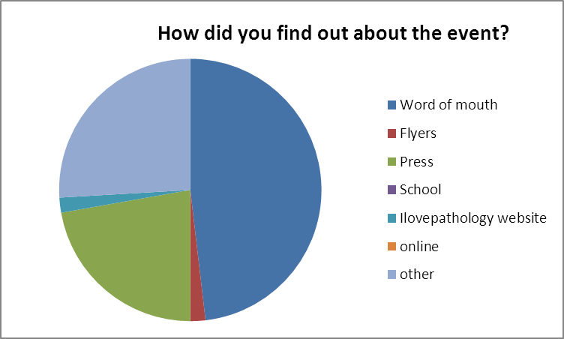
Other: passing by, hospital appointment, at work, direct email
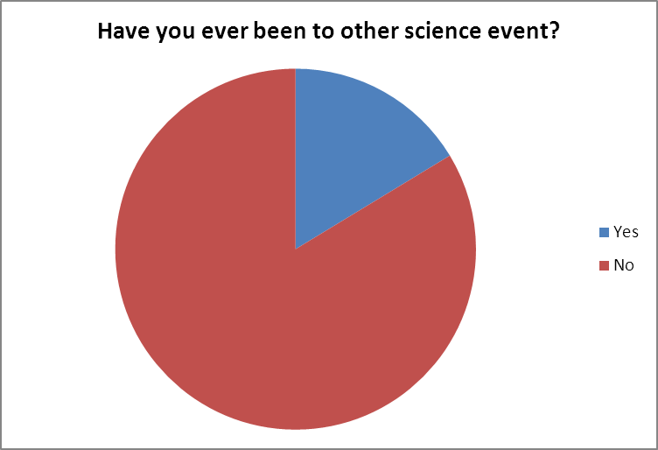

Did the public find the event:
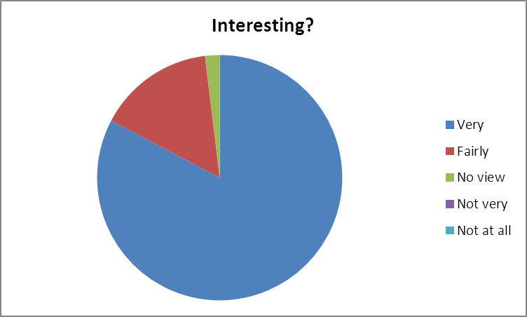
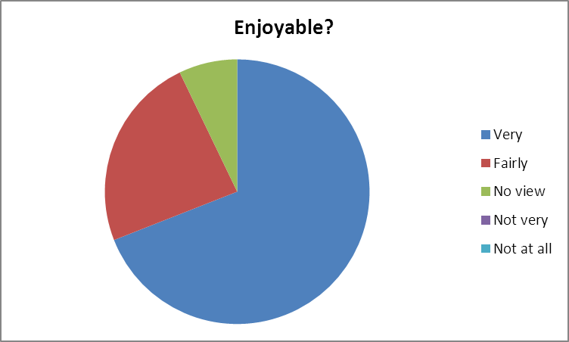

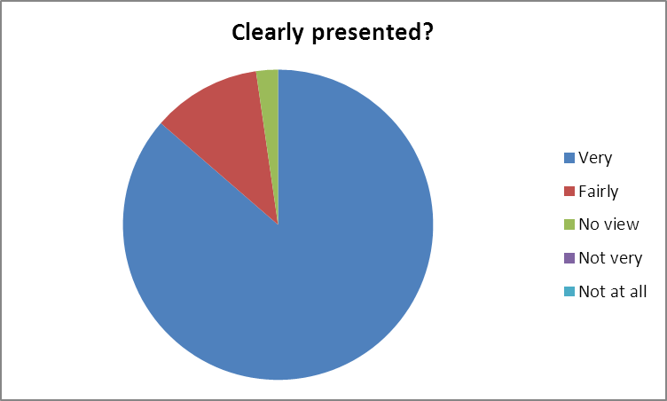
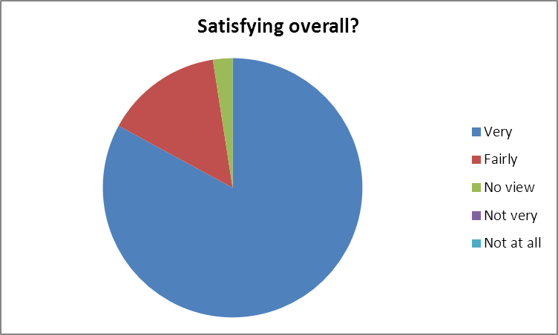
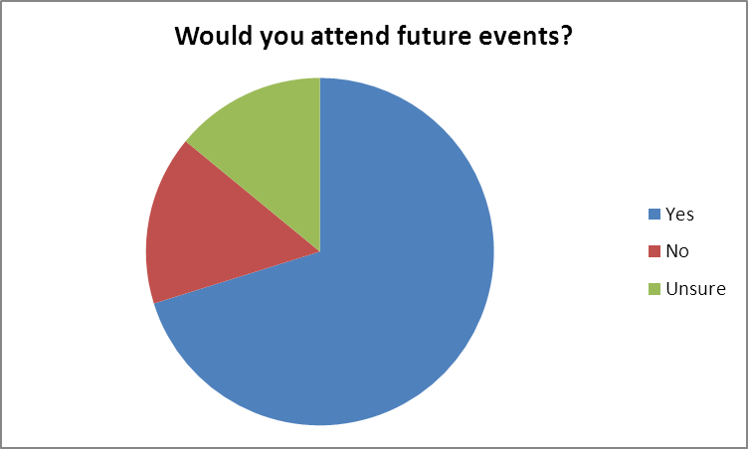
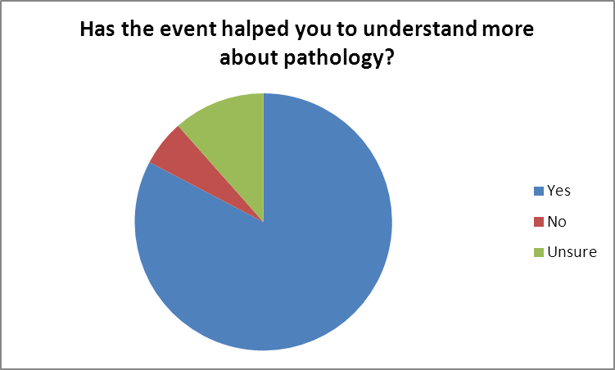
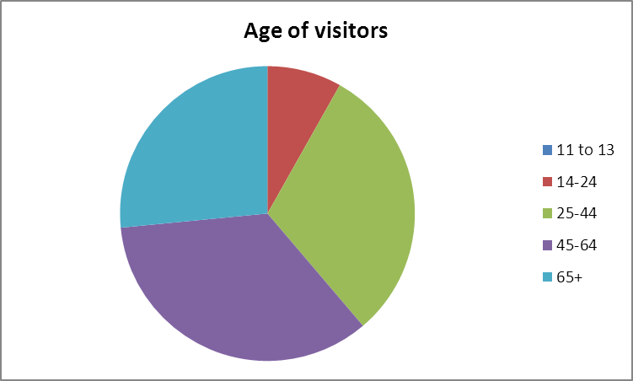
Comments included:
Not very private, long wait due to only one finger pricker
Would like to know more about CLL and non-Hodgkins lymphomas
Most interesting visit, excellent tour guide, am now more knowledgable
Very interesting to see behind the scenes
Very interesting and well presented
I found this very useful and enjoyed what I have learned from procedure
Excellent stall, approachable and friendly staff. A popular and well-used service
Good assistance in the testing/diagnosis of general public. Which of whom may not otherwise seek advice.
Very interesting, not as nerve racking as I thought
Interesting and informative
Very helpful and made me aware
Activity to fill in the waiting time for HbA1c testing
Team is great. Explain the whole process
It was something I'd like to have done and it gave me the opportunity to have it done there and then
Lovely staff
Very good
Girl demonstrating brought the subject alive.
Interesting, informative, useful
Dr on radio spoke really clearly about the subject
The HbA1c screen is a fantastic initiative, when will it be introduced generally in the UK?
I loved the fact the information stands were very interactive and the opportunity to see behind the scenes
The team work well together
The communication and general warmth of the staff
More available machines- long wait
Involve other disciplines and other tests such as VO2 max
Due to personal symptoms, putting my mind at ease

